Healthy Eating for Healthy Life

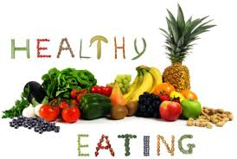
Healthy eating habit gives your body the nutrients which help you manage your weight loss and avoid health related problems.
Eating vegetables, fresh fruits and Home made meals, help to improve mood and remove mental health problems.
#Tuesday #Healthyjuice #EatHealthy #Vegetables #Healthyeating #Fitnesslifestyle
#Healthybody #Fitnesslife #Weightloss #Healthydiet #Healthylifestyle #Fitness
#Planmyhealth #HealthyFood #SchoolHealth #KidsHealth #CorporateHealth
#PreventiveHealth #BookDoctor #OnlineDoctor #BookAppointment
#WellnessIndia #FamilyHealth #HomeHealthcare

